***Online Grocery Shop***

ER Diagram Description:

‘Online Grocery shop’ provides online grocery products delivery.There are several products sold at different prices and quantities . Therefore, it must have few employees to initiate all the work and an admin who manages all employees. As COVID-19, safety issues are a very important factor; every employee must have a safety report. However, a similar safety report is acceptable for multiple employees. For each delivery, there must be one employee but an employee can perform multiple deliveries at different times or days. A product can be delivered multiple times but each delivery must contain one type of product. Each user can perform multiple deliveries but each delivery must be conducted by one user. A customer

can purchase multiple deliveries but each delivery must be purchased by one customer.

**Entities and Relationships:**

Every employee must have one safety report and each safety report must contain to at least one employee but similar

a safety report can be acceptable for multiple employees. Safety table depends on employee id to be uniquely

identified.

EMPLOYEE-SAFETY(M:1)

An employee can have multiple deliveries but each delivery must be conducted by one employee.

EMPLOYEE-DELIVERY(1:M)

A delivery must be conducted from one service but under a service, multiple deliveries can take place.

PRODUCT-DELIVERY(1:M)

Each user can perform multiple deliveries but each delivery must be conducted by one user.

USER-DELIVERY(1:M)

A customer can purchase multiple deliveries but each delivery must be purchased by one customer.

ADMIN-EMPLOYEE(1:M)

An admin can manage multiple employees. At the same time multiple employees can be mange by one admin.

**Er Diagram:**

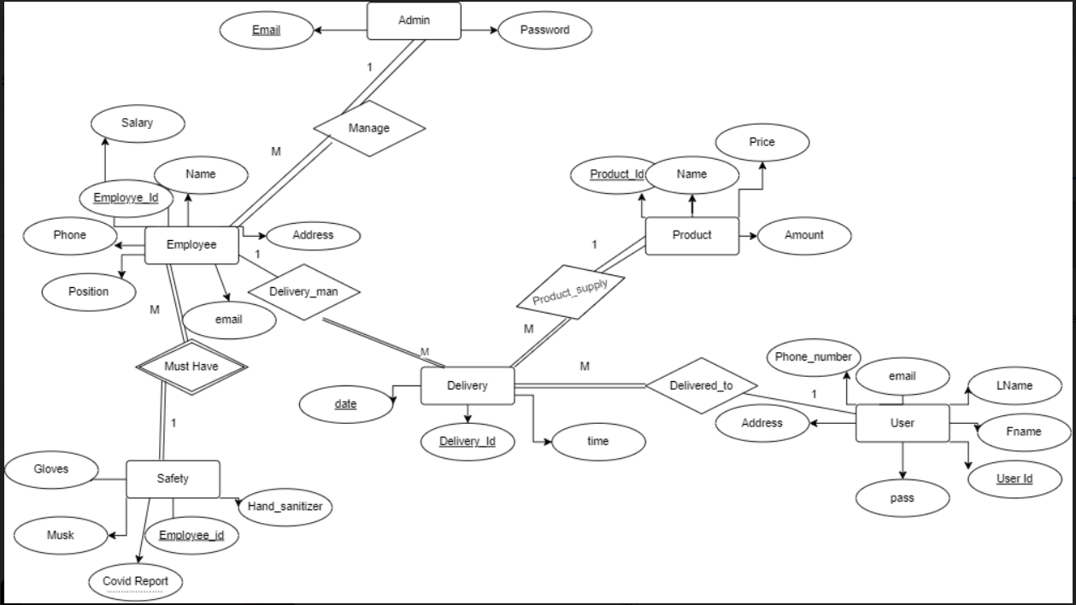

**Er Diagram to Relational Table:**

Employee

| Employee_iD | Name | phone | position | address | salary |
| --- | --- | --- | --- | --- | --- |

Admin

| Email | password |
| --- | --- |

Safety

| Covid_Report | Employee_iD | musk | gloves | Hand sanitizer |
| --- | --- | --- | --- | --- |

User

| User_iD | Fname | Lname | Address | phone | email | password |
| --- | --- | --- | --- | --- | --- | --- |

Products

| Products_id | Name | price | amount |
| --- | --- | --- | --- |

Delivery

| Delivery_id | Delivery_date | time |
| --- | --- | --- |